**The Annual General Meeting was held on 10.04.2008.**

**Members of the Society attended the meeting. The Asst. Manager addressed the members that, during the period ending on 31st March 2010 the organization have carried out several activities. The Chairperson further emphasized upon the significant achievements of the Society. The achievements of the Society during the period and talked about the future plans of the society. The achievements of the Society during the consideration was in form of successful implementation and handling of the program as below:**

**HIV AIDs Workshop**

Sensitizing the local Religious leaders (Maulavis and Madarasa teachers) towards HIV/AIDS: Workshop conducted at Laherpur on 12-13 September

SHRI PITAMBARA SHIKSHS SAMITI organized two days residential training for Maulanas and Maulavis from two blocks of on 12-13 September (2007) at Laherpur on 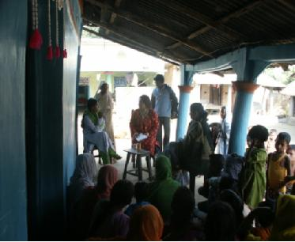HIV/AIDS awareness. The training was conducted by Dr Diwakar Singh

Who is the Medical Director of Medical Health (Regional AIDS Training Centre and Network in India, Lucknow).He gave comprehensive information about the spread and growth of HIV virus. According to him first case of HIV was detected in 1992 in Bihar. There are 70 reported deaths from AIDS in the state. However most people die from opportunistic infections like T.B, viral infections and Hepatitis B which makes the body weak. He gave information about the spread, causes and symptoms of HIV virus.

Mrs Swapna Majumdar, senior journalist visited SHRI PITAMBARA SHIKSHS SAMITI to document best practices. She interacted with adolescent girls groups and members of SHG at village Dondhi.

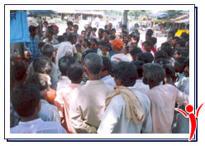Nukkad Natak as a communication strategy Nukkad Nataks are an important part of SHRI PITAMBARA SHIKSHS SAMITI communication strategy. These nataks are performed in local dialect Surjapuri to give message to the wider range of audiences. The actors enact two-three stories depicting each issues all interlinked with each other accompanied with music. The lead actor then asks the audience their reaction or what should have been done in case of early marriage of a girl. These nataks have two-fold advantage as they provide entertainment and thus help in gathering people and putting across message about something like AIDS in a simple way. Feedback is usually taken during the community meetings and their response is maintained in the registers. Our natak mandli is invited at block level functions like on AIDS awareness day etc which again help in targeting wider population.

The main issues that are addressed are

-AIDS awareness,   
-Right age of the marriage and space between the two children,   
-Equal treatment of girls and boys   
-Balanced diet for the girls  
-Hygiene and sanitation

**14th November**

SHRI PITAMBARA SHIKSHS SAMITIinvited Mr.Senthil Kumar to give away certificates in basic stitching and tailoring to the students of the skill training by SHRI PITAMBARA SHIKSHS SAMITI. On the occasion 21 girls and women of Talgaonand Dhondhi localities were given certificates.

**28th Jan 2008**

**VOCATIONAL & HANDICRAFT TRAINING PROGRAMME**

Keeping in the mind the objectives of removal of poverty by reducing the problems of 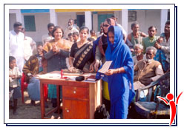employment the society has started a Vocational Training Program. In this training Women & Youths are provided training in different field like knitting & tailoring, Chikan Embroidery, Type and Shorthand, Food Processing, Fashion Designing Etc. by experienced trainers. The main aim of this program is to make the trainers so skilled that they may become self dependent and stand on their on feet.

Welfare program for street persons was organized by members of society on Human Right Day, Medicine, Fruits, Clothes and many other things were distributed among the street children. Primary Educational Program was also started by the volunteers. Books and other Educational material was also distributed free of cost among the Children.

FOR AND ON BEHALF OF THE MANAGING COMMITTEE

**(Auth. Signatory )**