The Annual General Meeting was held on 11.05.2007. All the members of the Society attended the meeting. The Manager addressed the members that, during the period ending on 31st March 2007 the organization have carried out several activities. After that the copy of the audited accounts were distributed among the members of showing the Receipt & Payments during the referred period. The Chairperson further emphasized upon the significant achievements of the Society. The achievements of the Society during the period and talked about the future plans of the society.

The achievements of the Society during the consideration was in form of successful implementation and handling of the program as below:

**Workshop on HIV/AIDS Awareness & Prevention:**

A Workplace Issue organized at Naipalapur, Sitapur Dist. on 30, 31 May and 1st June.

This workshop was organized by SHRI PITAMBARA SHIKSHS SAMITI. The main goal of the workshop was to promote sensitivity and awareness about HIV/AIDS among women and workers in the community, organized and unorganized sectors. The workshop was inaugurated by Shri Bharat Tripathi, MLC Sitapur. He said that the spreading HIV/AIDS awareness is the biggest challenge of the present government. This has to be tackled by NGOs, Government, trade unions and all the other agencies together. The three day sessions on technical, ethical,medical and legal HIV/AIDS issues were conducted by Dr.Gitanjali Kumari (BSACS), Dr Diwakar Tijaswi, Mr. Ashok Priyadarshi Advocate,.The workshop also saw presentations by Mr Gautam Dey on role of BVHA in HIV related activities, Mr. Amrendra Prasad and Mr. Nand Kumar Chaube on Yoga and HIV/AIDS. Mr. Kailash Bhagat member of network for people living with HIV/AIDS and HIV + himself shared his experiences with the participants. The field visit was a very important component of the workshop as it provided an opportunity to the participants to interact with the workers in both organized and unorganized sectors. The participants were taken to three different organizations. Dr U.C Tripathi said that this workshop on HIV/AIDS awareness for the NGO workers and trade union members would very useful when they will work at grass-root level. The workshop ended with a positive note with NGOS and Trade Unions agreeing to work together.

**HIV AIDs Workshop**

Sensitizing the local Religious leaders (Maulavis and Madarasa teachers) towards HIV/AIDS: Workshop conducted at Laherpur on 12-13 September

SHRI PITAMBARA SHIKSHS SAMITIorganized two days residential training for Maulanas and 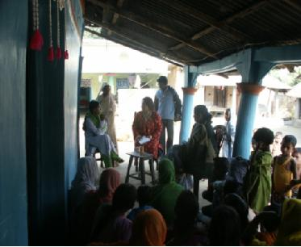Maulavis from two blocks of on 12-13 September (2007) at Laherpur on HIV/AIDS awareness. The training was conducted by Dr Diwakar Singh

Who is the Medical Director of Medical Health (Regional AIDS Training Centre and Network in India, Lucknow).He gave comprehensive information about the spread and growth of HIV virus. According to him first case of HIV was detected in 1992 in Bihar. There are 70 reported deaths from AIDS in the state. However most people die from opportunistic infections like T.B, viral infections and Hepatitis B which makes the body weak. He gave information about the spread, causes and symptoms of HIV virus.

Mrs Swapna Majumdar, senior journalist visited SHRI PITAMBARA SHIKSHS SAMITI on 15-16th December to document best practices. She interacted with adolescent girls groups and members of SHG at village Dondhi.

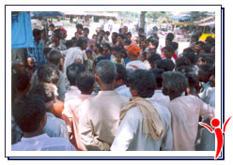  
Nukkad Natak as a communication strategy

Nukkad Nataks are an important part of SHRI PITAMBARA SHIKSHS SAMITIcommunication strategy. These nataks are performed in local dialect Surjapuri to give message to the wider range of audiences. The actors enact two-three stories depicting each issues all interlinked with each other accompanied with music. The lead actor then asks the audience their reaction or what should have been done in case of early marriage of a girl. These nataks have two-fold advantage as they provide entertainment and thus help in gathering people and putting across message about something like AIDS in a simple way. Feedback is usually taken during the community meetings and their response is maintained in the registers. Our natak mandli is invited at block level functions like on AIDS awareness day etc which again help in targeting wider population.

The main issues that are addressed are

-AIDS awareness,   
-Right age of the marriage and space between the two children,   
-Equal treatment of girls and boys   
-Balanced diet for the girls  
-Hygiene and sanitation

**Special Day Celebrations:**

SHRI PITAMBARA SHIKSHS SAMITI celebrates World AIDS Day, International Youth Day, International Women's Day and World Health Day by organizing special programmes and theme based discussions with the target population. The celebration of these days has made people aware of the importance of these days. It is also a medium through which we try to target maximum number of people. We invite guest speakers like doctors, BDOs and local 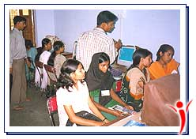leaders who have influence among the people to speak on issues related to girls' health and education.

**12th Oct**

KP Inter College celebrated its annual day. Mr. KP Singh inaugurated computer center at KP Inter College. He appreciated the efforts of SHRI PITAMBARA SHIKSHS SAMITI's work for the promotion of education and literacy. In the 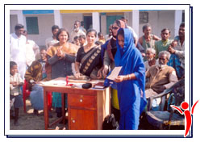afternoon he visited the Non formal center where children welcomed him with songs and presented him small gifts.

**14th November**

SHRI PITAMBARA SHIKSHS SAMITIinvited Mr.Senthil Kumar to give away certificates in basic stitching and tailoring to the students of the skill training by SHRI PITAMBARA SHIKSHS SAMITI. On the occasion 21 girls and women of Talgaonand Dhondhi localities were given certificates.

**01 December**

**World AIDS Day**

SHRI PITAMBARA SHIKSHS SAMITIcelebrated AIDS awareness day on 1 December 2006 at block headquarters. Meetings on AIDS awareness were conducted at both the places where BDO, BEO, doctors of referral hospital, local panchayat members and community members attended in large numbers. Nukkad nataks by the local natak mandli were performed at both the places.

**HEALTHCARE CAMP**

Women & Child Healthcare Program was organized to making women aware from about their health needs and nutrition was organized by the Society.

This Program was organized by the rural women in large number and it was felt by the attendant that this kind of programs are very useful in our villages where women were aware about their various informed about their health needs a very low. Further they were informed about various kinds of schemes formed and executed by the different Government department for welfare of the women either it is in education, employment or technical guidance. etc.

The women participating in the program were informed about need for education in the self reliance of the women. They realized the need for education and agreed to send their children particularly the girl child to school. Further it was resolved that the society will further organize similar program in the near future.

**12th January**

**International Youth Day:**

International Youth Day was celebrated on 12th January 2007 at the premises of KP Inter College. On this occasion a drawing competition was organized for the participants in which 50 girls belonging to two age-groups of 10-14 and 15 and above participated. The prizes were given by Mr.R.P.Singh the treasurer of SHRI PITAMBARA SHIKSHS SAMITI.

**28 January**

**AIDS & CANCER AWARENESS PROGRAM**

No disease has ever ended the life, the way AIDS does. HIV has become the biggest challenge before the mankind. As because it is an infectious disease the danger that is poses in immense. The only way to escape AIDS is to be aware of all the ways in which AIDS can take place.

A camp was organized by the Society at Block of District to educate people about the causes of 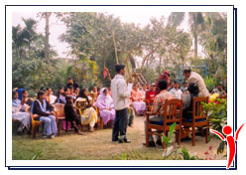AIDS and the precautions that one should take at the time of taking injection Blood etc., besides this the experts also described in details the reasons for cancer an ( the precautions needed to be taken generally to remain safe from cancer. The awareness campaign against included road shows and small meetings in the villages.

**8th March**

Dr.A.K.Tripathi, Asstt.Regional Director IGNOU, gave away the certificates to 29 girls of Rasulganj Nonformal Education Centre for successfully completing one year course in basic stitching and cutting. The programme was held at the premises of KP Inter College.

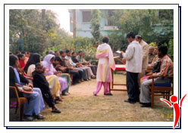**International Women's Day:**

A workshop was conducted at high school level on 8th March 2007 to mark the International Women's Day. It was attended by teachers of the school, women ward and panchayat members, marketing chairman and professors of the College. They addressed the high school students on women empowerment and importance of girls' health and education. The meeting ended with nukkad natak performance by the local natak mandli.

**15 April**

**Adolescent Reproductive and Sexual Health**

The well informed adolescents on sexual and reproductive health issues can play a decisive role in the better adolescent health in the country. Last year Foundation educates and provides information to the adolescent rural girls about their reproductive and sexual health.

This awareness is being implemented in 5 villages in three blocks. Focusing on reproductive health and sexual health issues by sensitizing them through group meetings, training programs and communication programs like drawing, painting and poster making etc. An important component of the program is to sensitize the parents and the community members to the needs of adolescents, as they are the ones who make all the decisions.

Our initiative are also addressing immediate concerns of adolescents i.e. delaying early marriage and pregnancy by taking an integrated approach of providing education and skill training side by side. Our nonformal education are the focal points for dissemination of information. We are using local haats for conducing community meetings followed by nukkad nataks in local dialect to target wider audiences.

Number of villages: 5  
Name of the villages:

1. Dondhi

2. Para  
3. Gauria  
4. Kasraila  
5. Raghubar Nagar

**AWARENESS PROGRAME FOR HANDICAPPED PERSONS**

The society has taken a number of steps including distribution of necessary equipments to the handicapped. Further it has plans to establish a school for the handicapped, other measures taken by the Society includes raising awareness about the handicapped so that they do not get separated in the society, apart from this the society arranged the painting Competition among the disabled to explore their talent in this field, society has plans to sell these paintings. The Society is planning to establish a school for the benefit to the disabled people.

**FAMILY PLANNING AWARENESS PROGRAM**

The population of our country surpassed 100 cores. This over population eats into all the developmental process. Lack of resources, food water job, healthcare facilities, schools & thousands of others problems owe their origins to this over population. The awareness about the benefits of having a very small family is still very low in our country particularly in the areas of the eastern Uttar Pradesh where the population density is disproportionately high.

Considering very high level of reluctance in part of the villages to adapt the family planning methods the population explosion has taken place causing deterioration in the available sources like food, education, housing, employment opportunities etc. A camp was organized by the society at block of district to raise awareness about the bad effects of the disproportionate growth in the population. Help of audio visuals techniques was taken to make presentation more effective. At the end of the camp condoms and contraceptive pills were distributed among the villagers.

The villagers were encouraged to bad adapt the notion of only one child per couple. Further it is observed that many couples anticipation of one male child give birth to a number of girl children. The attempt was made to teach them the reality of the modem era that virtually there is no difference between the male & female child. Both the boys & girls are equal in sense that the girls have the same opportunities as do have the boys. The participants highly appreciated this educational program.

There was no other business to transact. Therefore the meeting was terminated with vote of thanks to chair.

FOR AND ON BEHALF OF THE MANAGING COMMITTEE

**(Auth. Signatory )**